**Integral University, Lucknow**

**Department of Chemistry**

**Report**

**On**

**National Science Day, 2022**

**The National Science Day** was celebrated by Department of Chemistry, Faculty of Science on 28th February, 2022 to mark the discovery of the Raman Effect by Indian physicist Sir Chandrashekhara Venkata Raman on 28 February 1928. By celebrating this day as National Science Day, we show our dignity and respect to the famous Indian Physicist for his contribution in the field of science. Every year, this day was celebrated with a particular theme. This year, the theme was “Integrated Approach in Science and Technology for a sustainable future”. This year the program was organized on a virtual platform Google meet. The program was started on 28 Feb 2022 with inaugural address delivered by Dr Saimah Khan, followed by welcome address delivered by Prof. Abdul Rahman Khan, Dean Faculty of Science, HOD Department of chemistry.

The Chief Guest of the program was Prof. Javed Musarrat, Hon’ble Vice Chancellor, who enlightened us by sharing his research knowledge in his expertise field highlighted the significance of Science Day. Dr Syed Wajih Ahmad Naqvi, who was Distinguished Visiting Professor, Dept. of Earth Sciences, IIT Kanpur, was the Keynote speaker of this program and provided the complete insight of the topic with excellent diagrammatic representations, pictures and graphs explaining the various aspects of Earth Science. The program concluded with the vote of thanks proposed by the Prof. M.A. Khalid, Head Dept. of Environmental Science and Dean Student Welfare.

**Event at a glance**

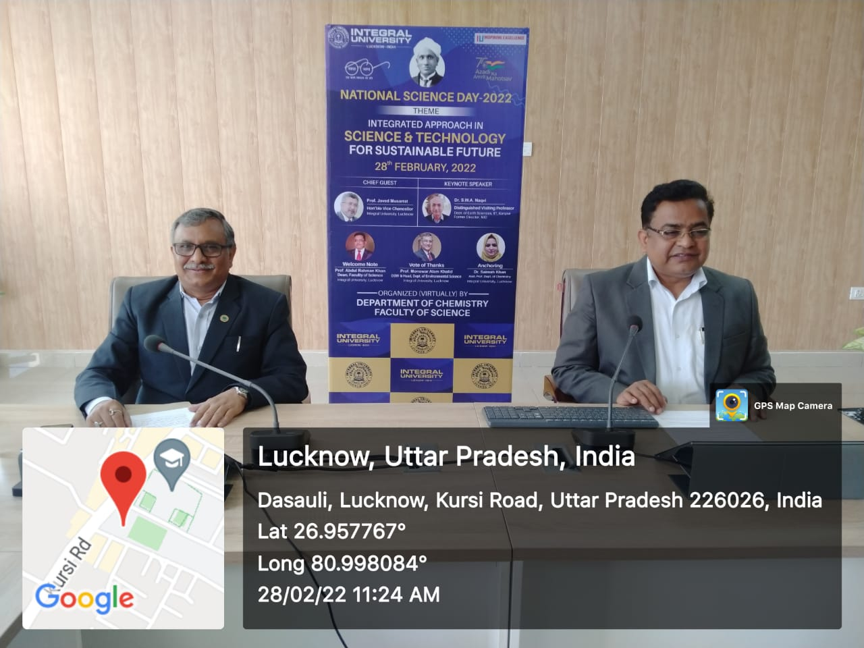 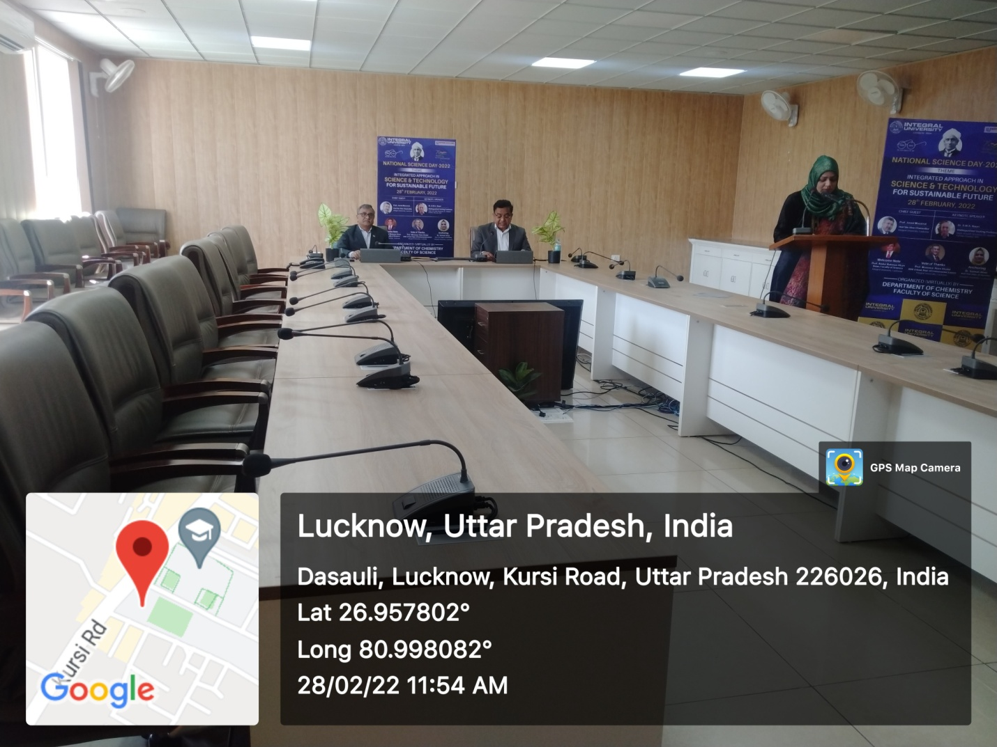

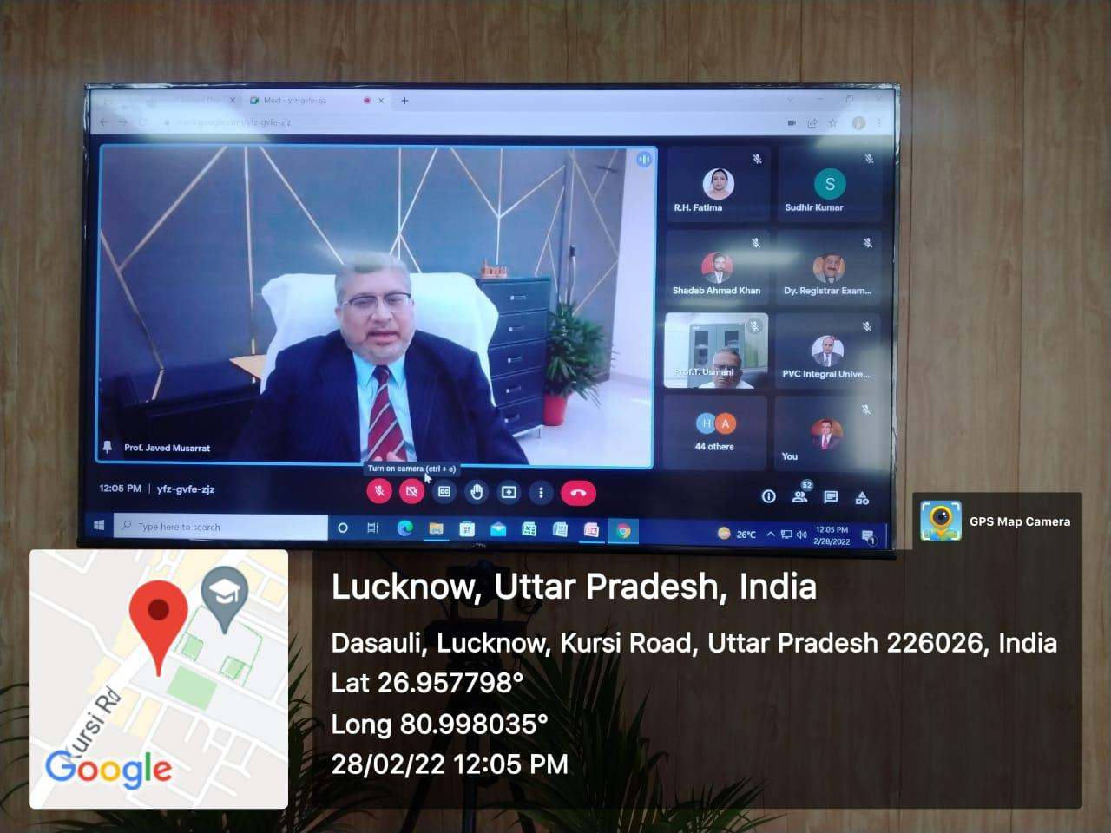 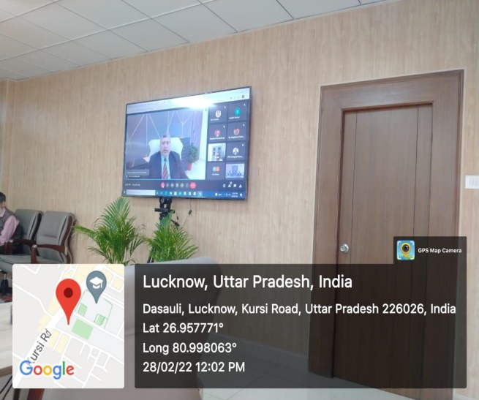

Submitted by

Prof. Abdul Rahman Khan

Dean, Faculty of Science,

Head, Department of Chemistry

Integral University, Lucknow